STAC32 Assignment #1
Grisham Nathan
September 14, 2017

4.

a)
library(tidyverse)
## Loading tidyverse: ggplot2
## Loading tidyverse: tibble
## Loading tidyverse: tidyr
## Loading tidyverse: readr
## Loading tidyverse: purrr
## Loading tidyverse: dplyr
## Conflicts with tidy packages ----------------------------------------------
## filter(): dplyr, stats
## lag(): dplyr, stats
url="http://www.utsc.utoronto.ca/~butler/c32/global.csv"
input=read_csv(url)
## Parsed with column specification:
## cols(
## warehouse = col_character(),
## size = col_integer(),
## cost = col_double()
## )
input
## # A tibble: 10 x 3
## warehouse size cost
## <chr> <int> <dbl>
## 1 A 225 11.95
## 2 B 350 14.13
## 3 A 150 8.93
## 4 A 200 10.98
## 5 A 175 10.03
## 6 A 180 10.13
## 7 B 325 13.75
## 8 B 290 13.30
## 9 B 400 15.00
## 10 A 125 7.97
Reads data from the CSV file from the URL and stores in variable. Afterwards, it is then outputted in a data frame. The data frame has 10 rows and 3 columns.

b)
ggplot(input,aes(x=size,y=cost))+geom_point()
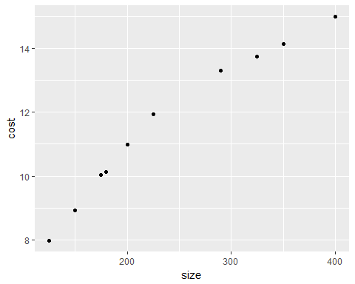 Creates scatterplot using the data frame, using the size column as the x-axis and the cost as my y-axis. The points are added according to corresponding size and cost of each observation.

c)
There is a positive relationship between size and cost. As size increases, cost also increases.
The trend appears to go from bottom left to top right.
A straight regression line would describe the trend appropriately, however their are some points that slightly deviate from the regression line.

d)
ggplot(input,aes(x=size,y=cost,colour=warehouse))+geom_point()
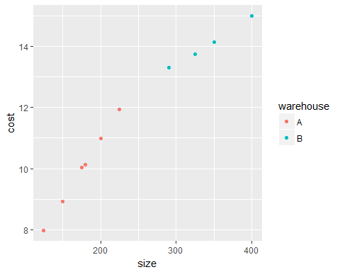
I think size determines which warehouse an incoming shipment goes to. From the data given and the scatterplot I created, the largest shipment to warehouse A is 225000 parts and the smallest shipment to warehouse B is 290000 parts. It seems that whether a shipment has more or less than a certain number of parts (Definitely between 225000 and 290000 parts), is what determines which warehouse the shipment goes to.
As a result, we can infer that products below this specified limit goes to warehouse A and products above this specified limit go to warehouse B.

